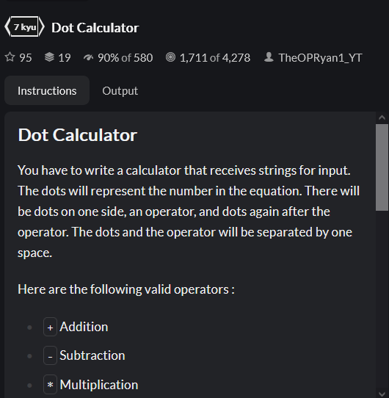

* First convert input into array of [integer, operation, integer], via the split and map methods.
* Dot lambda function made for generating string of dots based on some length,
* Conditional logic based on operation, return string of dots of length of result after operation

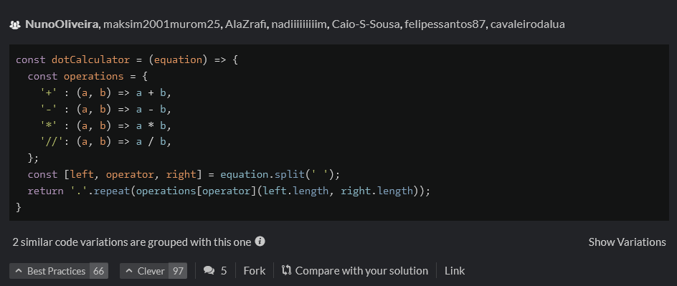

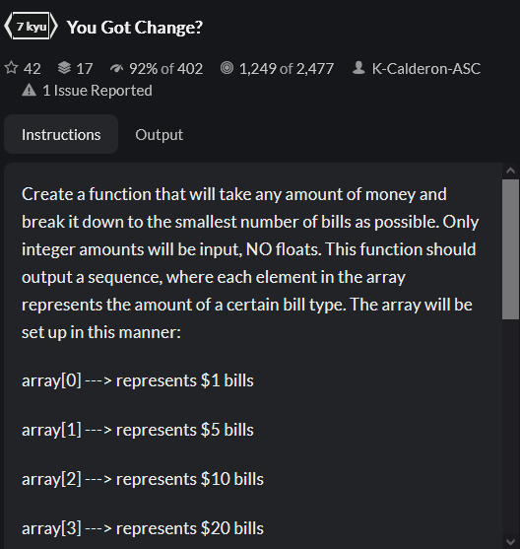

* Created variable holding amount units, empty output array, and current amount value,
* We then iterate over the amounts from largest (100) to smallest (1),
* If the current value is greater than or equal to the current unit (units[i]), then we can give this as change,
* To give it as change, we add the floor division to the front of the array,
* We also change the current amount to be equal to the remainder of this division,
* If the current value is less than the current unit, we similar append (unshift) a 0 to the front of the array



